*** This is a template article for submissions to IEEE Earthzine.
Pay special attention to the requirements. Key points are in red.

Earthzine references Associated Press (AP) style for its articles.
All articles must include images. We suggest including at least three images per article or one image for every 400 words. Submit your document in Microsoft Word or via Google Docs.

All articles should be classified by Topic, Category, Region, Interest Level, and Tags. All original stories should be classified as Original under Category, and include the name of the theme and year, if applicable (such as Coastal Environments 2016). Other Categories may be added by the Managing Editor, including Op-Ed, Announcements, or GEO/GEOSS News.

- Topic (pick at least one: Agriculture, Biodiversity, Climate, Disasters, Ecosystems, Education, Energy, Health, Oceans, People, Policy, Quick Looks, Reviews, Sustainability, Technology, Water, Weather)

- Region (pick at least one: Africa, Asia, Australia, Europe, Global, India, North America, Out of this World, Pacific Islands, Polar, South America)

- By Interest Level (Generalist or Specialist)

- Tags: More specific tags also should be included, to note additional topics, agencies, etc.

Topic: Oceans, Ecosystems
Category: Original, Coastal Environments 2016
Region: Global
Interest Level: Specialist
Tags: grey seals, marine mammals, northwest Atlantic Ocean, Sable Island, Ocean Tracking Network (OTN), Damian Lidgard, Sara Iverson, tracking, Argos, telemetry, satellite

All articles should include a headline, byline and short squib or summary. The squib appears on the landing page when the article is posted.
Grey Seals of Sable Island: Seal Biologists Collect Data Beneath the Waves

By Damian Lidgard and Anja Samardzic

Squib: The Ocean Tracking Network’s grey seal bio-probe project equips seals with tracking technology, giving researchers an unprecedented view of their behavior and environment.

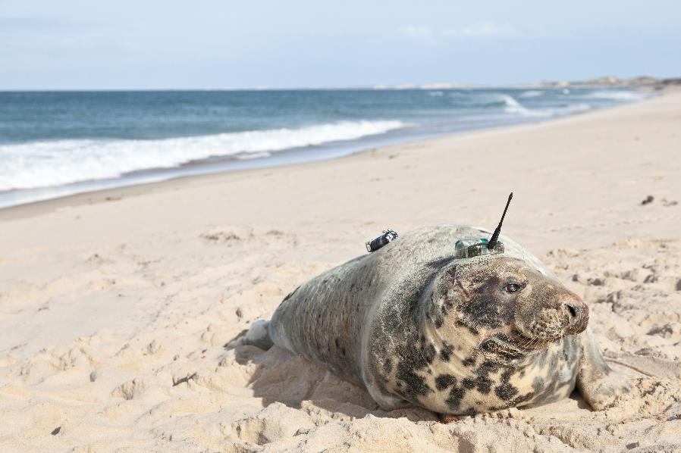
Grey seal outfitted with tacking device on Sable Island. Image Credit: Damian Lidgard

All photos should be 1600 pixels wide, be pasted into the Word document, and include caption and credit information, all in italics. There should be a hyperlink over the source of the image if it’s available online. Horizontal images are preferred. There are several options for resizing photos.

The Ocean Tracking Network (OTN)hyperlinks to specific organizations or more information should be included in the text as appropriate is a worldwide aquatic animal tracking network headquartered at Dalhousie University in Halifax, Nova Scotia, Canada. OTN’s mission is to generate knowledge on the behavior, movement and distribution of aquatic animals to advance the conservation and sustainable use of marine and freshwater species. OTN is tracking more than 100 keystone, commercially important and endangered species, including marine mammals, sea turtles, squid, benthic crustaceans (lobsters, crabs) and fish, including sharks, sturgeon, eels, tuna, salmonids and cod.

References
If applicable include references in the text and follow IEEE citation style. In general, cite anything that includes statistics or figures, and credit a source when a sentence references material from a source.

Hyperlinks in references should be active. See IEEE citation examples below.

[1] B. Klaus and P. Horn, Robot Vision. Cambridge, MA: MIT Press, 1986.

[2] L. Stein, “Random patterns,” in Computers and You, J. S. Brake, Ed. New York: Wiley, 1994, pp. 55-70.

[3] R. L. Myer, “Parametric oscillators and nonlinear materials,” in Nonlinear Optics, vol. 4, P. G. Harper and B. S. Wherret, Eds. San Francisco, CA: Academic, 1977, pp. 47-160.

All articles should include a short author biography at the end, no more than two sentences long. The bio can include a Twitter handle at the end, in this format: “Follow Samardzic on Twitter @ASamardzic.” The handle should include a hyperlink to the person’s Twitter profile.
Anja Samardzic is the communications officer for Ocean Tracking Network.

Damian Lidgard is a research associate at Dalhousie University and an investigator on the OTN grey seal bio-probe project.

-end-

